**Understanding the First Part into Compiler Design**

Andres Choque

Liberty University: School of Business

CSCN 434: Compiler Design - Lexing and Parsing (LLVM)

November 13, 2022

**Understanding the First Part into Compiler Design**

**Screenshots of the functionalities**

1. **Add the ability to recognize division**

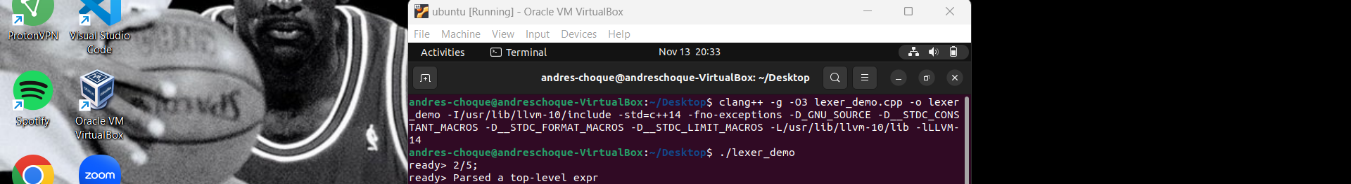

**Figure 1:** displays 2/5

1. **Add the ability to recognize logical “or” using the “|”**

**Figure 2:** displays x|y

1. **Add the ability to recognize logical "and" using the "&"**

**Figure 3:** displays x&y

1. **Add the ability to do logical "exclusive or" using the "^"**

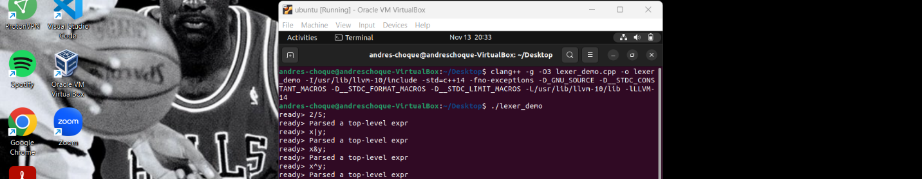

**Figure 4:** displays x^y

1. **Add functionality to recognize a new identifier ("logic")**

**Figure 5:** displays the logic function that passes x y

**Full picture:**

**Figure 6**